Pokhara University

Level: Bachelor | Semester – Spring | Year : 2008
Programme: BE |  | Full Marks: 100
Course: Principle of Programming Languages |  | Time : 3hrs.

Candidates are required to give their answers in their own words as far as practicable.
The figures in the margin indicate full marks.

Attempt all the questions.

 | - How does automatic execution be dissimilar with manual execution? Explain the read-execute cycle with its steps.  - What are the Amplicative and Reductive tools? Explain the Phenomenology of programming languages.  - Why does not support both readability and writeability by a program language? Justify. | 5  5  5
 | - Illustrate looping in FORTRAN by writing a program to find out the cube root of the first ten natural numbers.  - "Optional variables declarations are dangerous in FORTRAN programming". Justify the statement. | 8  7
 | - Programming language needs syntactic structure, why? How does machine independence support better syntactic structure? Explain it in the light of ALGOL-60.  - "Pass by name is not only expensive but also dangerous". Justify with example. | 10  5
 | - How does a language become generation programming language? Define that list is primary data structure constructor in LISP.  - Translate the following expressions into LISP  i) 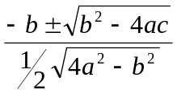 ii) 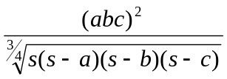 | 7  8
 | - Differentiate between followings (Any Five only):  - Computed goto and Complex goto  - Abstract Syntax Tree and Parse Tree  - Dangling ambiguity and Dangling references  - Lambda expression and s-expression  - Numeric atom and non-numeric atom  - Programming paradigm and programming domains  - Why do naming structure essential for programming? Explain the Name structure of ALGOL-60 | 10  5
 | - How is a class represented in small talk? Explain in detail with an example.  - What are the three forms of message templates in small talk? Illustrate. | 8  7
 | Write short notes on (Any Two):  - Message Passing and Returning in Smalltalk.  - Characters of good programming language  - Zero-one-infinity principle  - Contour diagram | 2×5

